**Classification of a living organism**

One of the first decisions most scientists have to make when classifying something for the first time is if it is alive. What does it mean to be alive? What is the difference between us and the chairs we sit on? Both plants and animals and considered to be alive. What do we have in common that makes us alive?

It has taken many years of observation and discussion for scientists to develop eight characteristics that all living things have plants, animals and even microorganisms and bacteria have in common. To remember all eight characteristics, just remember MR N GREWW

M – Living things can MOVE by themselves

R – Living things can REPRODUCE

N – Living things need NUTRITION

G – Living things GROW as they get older

R – Living things RESPOND to change

E – Living things EXCHANGE GASES with their environment

W – Living things produce WASTES

W – Living things require WATER

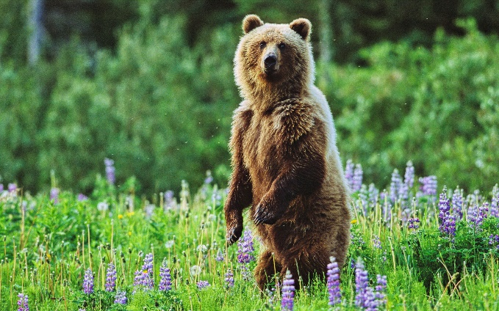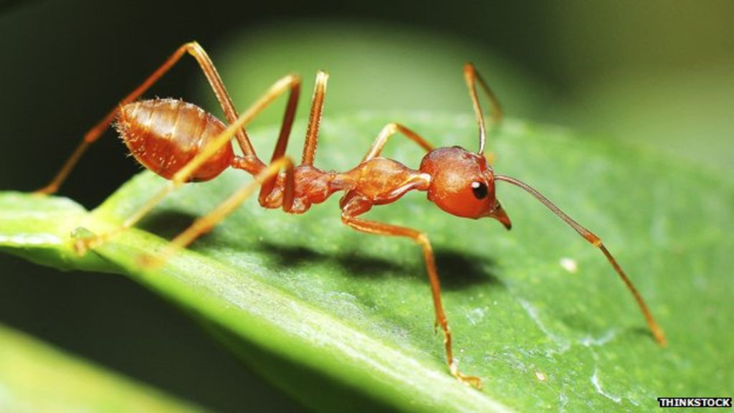

**Questions**

1. The system scientists use to group things divides them first into two groups. What are the two groups?
2. With a partner or by yourself, decide whether each of the items meets the requirement to be classified as a living thing (MR N GREWW). Eucalypt tree, water, paper, robot, leather belt, wombat, roast chicken, chair.
3. Decide whether each should be classified as a living or non-living.
4. Are any of the items listed in your answer dead? Explain your answer
5. Use the characteristics of a living thing to describe a bushfire.
6. Is a bushfire alive? Explain your answer